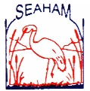  Public School  Parents & Citizens Association | MINUTES  13 June 2012

Meeting opened at 7:30pm.

ITEMS |  | MINUTES
1. Introductory Matters
Welcome & Recording of Attendance |  | Kerri McCaw, Caitlin Moroney, Rebekah Flynn, Carly Clarke, Rebecca Muddle, Tracey Morris, Allison Richards, Sally Ross, Liane Buckley, Jim & Melanie Meredith.
Apologies |  | Craig Partridge, Paul Le Mottee, Shawn Armitage, Karen Codrington, Karen Phillips, Rebecca Renshaw.
Minutes of Last Meeting |  | The minutes of the previous meeting be taken as read and moved as correct. Moved C Clarke. Seconded J Meredith CARRIED.
2. Reports
Principal  Report read by Kerri McCaw |  | 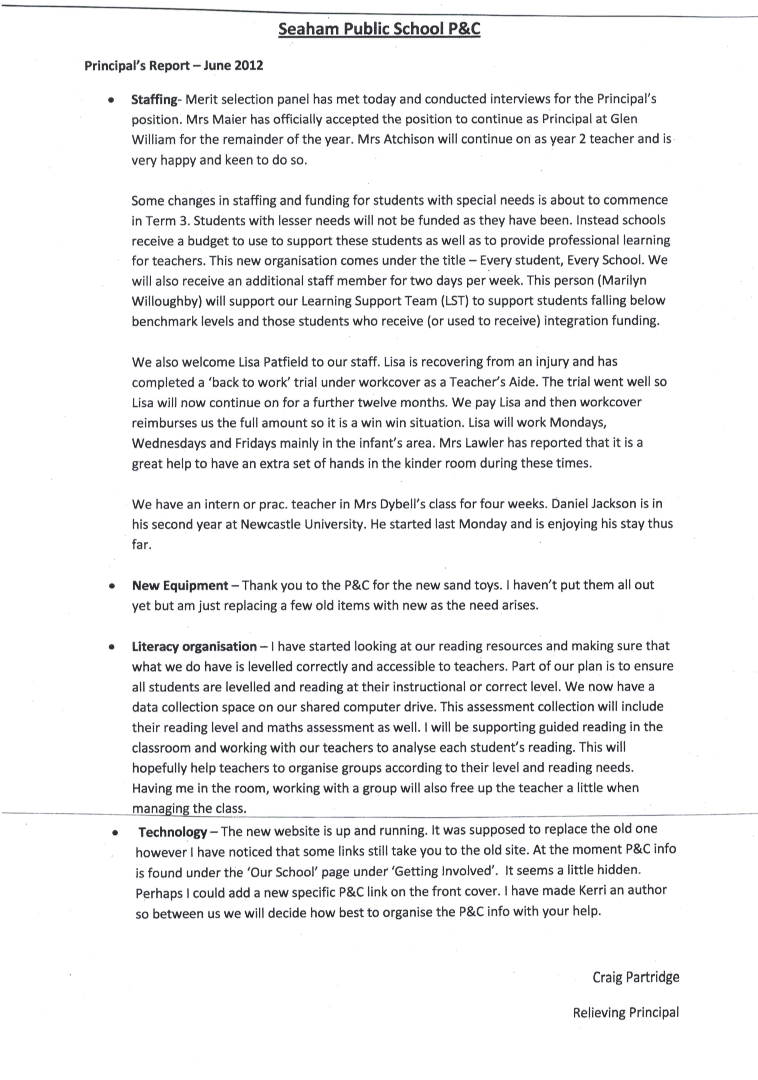
Treasurer |  | A Richards advised:  The current balance, as per the statement is $32953.16 which includes the term deposit in the amount of $19990.00.  Motion: To close CBA account. Moved T Morris. Seconded S Ross. CARRIED.
Canteen Committee |  | Pie drive: Orders are due in tomorrow.
Uniforms |  | Carly Clarke reported:  There have been some queries from parents as to whether tracksuits can be worn every day. To clarify this matter, Craig Partridge placed a notice recently in the newsletter to say they can be worn every day as part of the winter uniform.
Correspondence |  | T Morris advised:  Incoming correspondence:  - P & C Journal  - Letters from Holiday Coast Credit Union – unsuccessful in application  - Shacks and sheds re quoting for building work  - Insurance cheque for Canteen claim in the amount of $189.50.  Outgoing correspondence:  - Nil
3. General Business and Other Business Arising
Masters BBQ | Caitlin Moroney has been successful in getting the Saturday the weekend before Fathers’ Day – 25/8/12 from 11am-2pm.
Mural | Carly Clarke has spoken with the people involved in painting the murals in Kurri Kurri and unfortunately it would be very expensive to use their services.  Liane Buckley has a friend who paints murals and may be able to quote.  Year 6 are planning their gift which may include a mosaic or mural. We will need to liaise with them too.
Drive in movie night | Still planning for Ice Age 4 early in Term 3.
Woolies Earn and Learn | Tracey Morris and family have been working hard sticking stickers onto sheets. We already have over 21,000 stickers.
Coles | Sticker program starting soon.
Fundraising | Birthday cards: The boxes are due back and 40 families have not yet returned them but letters have now been sent. The fundraiser should raise $900-$1000.  Tea towel fundraiser: The drawings have been done. Order forms are going out soon.
Sensory Garden | The consultant, Tash, might come to the next meeting and speak further about the costs of each element and the total cost. 16 people voted electronically prior to the meeting to spend $300 for the plans and costing.  We have not been successful in receiving a grant from the NRMA but we may try again next year. We have not yet heard from Hunter Water or Landcare. Tash may let us know if there are others we could apply for that she is aware of.
Sand pits | A motion was moved to purchase one of the pre-made sand pits. Moved K McCaw. Seconded R Flynn. CARRIED.  Hunter Quarries are happy to donate the sand needed and Kerri McCaw is going to place a notice in the newsletter to organise a school parent or two who can pick up the sand and bring it to the school.
Agenda items | Any items for inclusion in the agenda should be emailed to Kerri McCaw on gav_kez@optusnet.com.au. Please note there is an underscore between gav and kez.
Authority to Sign Cheques | - Caitlin Moroney $492.03 for Sand pit toys  - LW Reid $168.85  - Gazas Apparel $872.47  Moved by S Ross. Seconded C Clarke. CARRIED.
Next Meeting | Wednesday the 18th of July 2012.
Meeting Closed at 8:25pm.

